ECONOMICS
Adam Smith is termed as the father of modern economics, proposed the definition of Economics as the ‘study of wealth’ in his famous book, “The Wealth of Nations”. He said that Economics is a science of wealth that studies the process of production, consumption, and accumulation of wealth.
Alfred Marshall defined Economics as “It is the study of mankind in the ordinary business of life. It examines that part of the individual and social activities that are closely related to the attainment of material resources, to welfare, and its utilization”.

NATURE AND SCOPE OF ECONOMICS
- Nature of Economics:
  - Economics – as a Science and as an Art
    - (i) Economics as a Science: A subject is considered science if:
– It is a systematised body of knowledge which studies the relationship between cause and effect.
– It is capable of measurement.
– It has its own methodological apparatus.
– It should have the ability to forecast.
– If we analyse economics, we find that it has all the features of science
    - (ii) Economics as an Art: A discipline of study is termed an art if it tells us how to do a thing that is to achieve an end (objective). It is noteworthy that the final justification for studying economics lies in the possibility of our ability to use it for solving economic problems faced by us. Prof. J. M. Keynes says that “An art is a system of rules for the achievement of a given end.”
  - Economics as Positive Science and Economics as Normative Science
    - Positive Science: A positive or pure science analyses cause and effect relationship between variables but it does not pass value judgment.
    - Normative Science: As normative science, economics involves value judgments. It is prescriptive in nature and described ‘what ought to be’ or ‘what should be the things’. ’. For example, the questions like what should be the level of national income, what should be the wage rate etc.,.
    - SCOPE OF ECONOMICS
      - (i) Micro Economics
      - (ii) Macro Economics
      - (iii) International Economics
      - (iv) Public Finance
      - (v) Development Economics
      - (vi) Health Economics
      - (vii) Environmental Economics
      - (viii) Urban and Rural Economics

DEMAND ANALYSIS
In common, demand means the desire for an object. But in economics demand is something more than this. According to Stonier and Hague, ―Demand in economics means demand backed up by enough money to pay for the goods demanded‖. This means that the demand becomes effective only it if is backed by the purchasing power. In addition to this, there must be willingness to buy a commodity.
Thus demand in economics means the desire backed by the willingness to buy a commodity and the purchasing power to pay.
In the words of ―Benham‖ ―The demand for anything at a given price is the amount of it which will be bought per unit of time at that Price‖.
Hence, demand refers to the amount of commodity which an individual consumer is willing to purchase at given price in a given period. The demand is said to exist when the following three conditions are fulfilled.
  - Desire to purchase
  - Ability to pay
  - Willing to pay
Ex: A beggar may have desire to purchase a car but he cannot pay money for it. Ex: A miser does not purchase a car but he can pay money for it.

DEMAND FUNCTION
Demand function is a function which describes a relationship between one variable and its determinants. The demand function for a good relates the quantity of good which consumers demand during a given period to the factors which influence the demand. Quantity demanded is dependent variable and all the factors are independent variables. The factors can be built up into a demand function. The demand function can be mathematically expressed as follows:
Q = Quantity demanded f = Function of
P = Price of goods itself I = Income of consumers
T = Taster and preferences P₁..P_{n} = Price of related goods
E_{P} = Expectation about future price E_{I} = Expectation about future income S = Size of the Population
D = Distribution of Customers
A = Advertisement
O = Other factors
Q = f(P, I, T, P₁..P_{n}, E_{P}, E_{I}, S, D, A, O)

LAW OF DEMAND:
Law of demand shows the relationship between price and quantity demanded of a commodity in the market. In the words of Marshall, ―the amount demand increases with a fall in price and diminishes with a rise in price‖.

The law of demand states that “ other things remaining constant, the higher the price of the commodity, the lower is the demand and lower the price, higher is the demand”. It is called as ceteris paribus (Latin phrase meaning other things constant.)
The law of demand may be explained with the help of the following demand schedule.

Demand Schedule: Demand Curve:
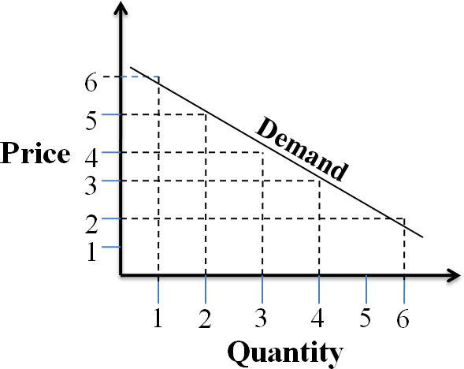
Price of Apple  (In. Rs.) | Quantity  Demanded
2 | 6
3 | 4
4 | 3
5 | 2
6 | 1

When the price falls from Rs. 6 to 5, quantity demand increases from 1 to 2. In the same way as price falls, quantity demanded increases. On the basis of the demand schedule, we can draw the demand curve. The above demand curve shows the inverse relationship between price and quantity demanded of apple. It is downward sloping.

Assumptions:
Law of demand is based on certain assumptions:
- There is no change in consumers taste and preferences.
- Income should remain constant.
- Prices of other goods should not change.
- There should be no substitute for the commodity
- The commodity should not confer at any distinction
- The demand for the commodity should be continuous
- People should not expect any change in the price of the commodity

EXCEPTIONS TO LAW OF DEMAND
According to law of demand, other things being constant, as the price increases, the demand for the commodity decreases and vice-versa. But this is not true all the time. In some cases, as the price increases, the demand for the commodity will also increase and the demand decreases when the price decreases. All these cases are considered as exceptions to the law of demand.

When price increases from OP to Op1, quantity demanded also increases from OQ to OQ1 and vice versa. The following are the exceptions to the law of demand.

Giffen goods or Giffen paradox:
The Giffen good or inferior good or cheap good is an exception to the law of demand. The demand for these goods varies directly with the variations in prices i.e., there exists direct relation between the quantity demanded and the price of the commodity. Giffen goods may or may not exist in the real world.

Giffen goods are named after
Sir Robert Giffen. He has conducted a survey on American laboring families who consume bread and meat. The survey revealed that they spend more of their income on bread because it is their staple food or main food and less of their income on meat. When price of bread increases, after purchasing bread, they don‘t have surplus money to buy meat. So, the rise in the price of bread forced the people to buy more bread by reducing the consumption of meat and thus raised the demand for bread. The goods like bajra, barley, gram, millets, vegetables fall under the category of Giffen goods.

Goods of status
In some situations, certain commodities are demanded just because they are expensive or prestige goods and are usually used as status symbols to display one‘s wealth in the society. Examples of such commodities are diamonds, air conditioned car, duplex houses etc. as the price of these commodities increase, they are more considered as status symbols and hence their demand gets raised. This goes against the law of demand.

Ignorance:
Sometimes, the quality of the commodity is Judged by its price. Consumers think that the product is superior if the price is high. As such they buy more at a higher price.

consumer expectations of future prices
If the price of the commodity is increasing, the consumers will buy more of it because of the fear that it increase still further. Similarly, if the consumer expects the future prices to decrease, he may not purchase the commodity thinking that the good may be of bad quality. This violates the law of demand.

Fear of shortage:
During the times of emergency of war, People may expect shortage of a commodity. At that time, they may buy more at a higher price to keep stocks for the future.

Necessaries:
In the case of necessaries like rice, vegetables etc. people buy more even at a higher price.

DETERMINANTS OF DEMAND
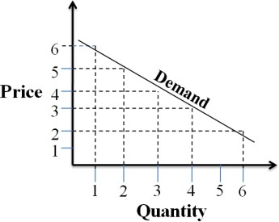
There are several factors or determinants that affect the individual demand and market demand for a product. These factors are economic, social as well as political factors. The effect of all the factors on the amount demanded for the commodity is called Demand Function. These factors
are as follows:

Price of the Commodity:
The most important factor-affecting amount demanded is the price of the commodity. The amount of a commodity demanded at a particular price is more properly called price demand. The relation between price and demand is called the Law of Demand. The demand for a commodity varies inversely with its price. A decrease in price increases the purchasing power of consumers and an increase in the price decreases the purchasing power of the consumers.

Income of the Consumer:

The second most important factor influencing demand is consumer income. Individual consumer‘s income determines his purchasing ability. When other things remaining constant, if income increases, demand increases and vice-versa. An increase in income makes an individual to buy many commodities. The effect of income on demand can be analysed for normal goods, perishable goods and inferior goods.
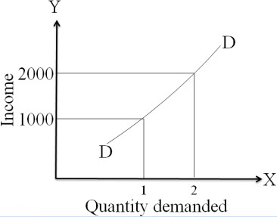
    - Normal goods: Usually, the demand for a normal good goes in the same direction with consumer‘s income i.e., demand for normal goods is directly related to consumer‘s income.
Income | Demand
1000 | 1
2000 | 2

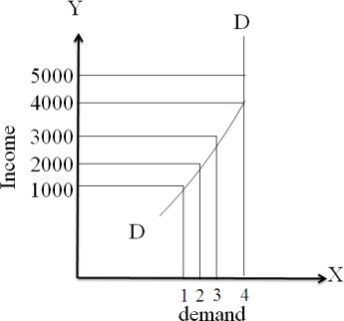
    - Perishable goods: For perishable goods like foods, fruits, meat, vegetables, milk etc., whose life is very short, the quantity demanded raises with an increase in income, but after a certain level it remains constant even though the income raises.
Income | Demand for  milk in Kg.
1000 | 1
2000 | 2
3000 | 3
4000 | 4
5000 | 4

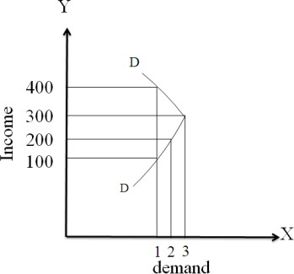
    - Inferior goods: The goods for which the demand decreases even though the income level increases are inferior goods or cheap good or ordinary goods.
Income (Rs.) | Demand for  ordinary ice-cream
100 | 1
200 | 2
300 | 3
400 | 1

Prices of related goods:
In a given market, if the price of one good influences the quantity demanded
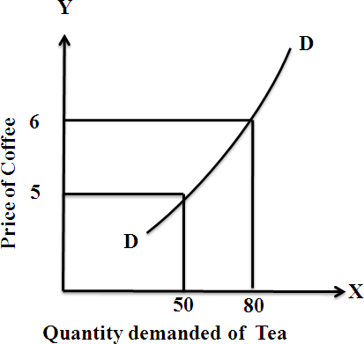
of another good, these two goods are said to be related goods. Two commodities in a given market are related to each other either as Substitutes or Complementary goods.
- Substitutes: When a want can be satisfied by alternative similar goods, they are said to be substitutes to each other. Ex: Tea and Coffee, Santhoor soap and Lux soap etc. The below graph indicates that as the price of coffee increases, the demand for tea increases.

Price of Coffee (Rs.) | Demand for Tea
5 | 50
6 | 80

There is direct relation between price of coffee and demand for Tea.

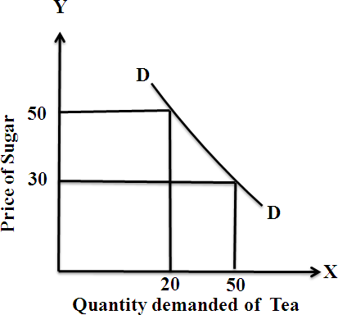
- Complementary goods: When a want can be satisfied by two or more goods in a combination. These goods are termed as complementary goods. In other words, if the price of one good increases, the demand for another good will decrease. Ex: Bread and Butter, Pen and Ink, Car and Petrol, Sugar and Tea and Shoe and Socks etc. The below table and graph indicate the indirect relationship between price of one good and demand for one good.

Price of Sugar (Rs.) | Demand for Tea
30 | 50
50 | 20

Tastes and habits of the Consumers:
Irrespective of price of good and income levels of consumers, demand for many goods depends on consumers‘ tastes and habits. For example, the demand for ice-creams, chocolates, alcohol, tea, cigarettes etc depend on individual tastes and habits. In cases like, a strict vegetarian does not demand for meant at any price, whereas a non-vegetarian will buy meat at any price.

Wealth:
The amount demanded of commodity is also affected by the amount of wealth as well as its distribution. The wealthier are the people; higher is the demand for normal commodities. If wealth is more equally distributed, the demand for necessaries and comforts is more. On the other hand, if some people are rich, while the majorities are poor, the demand for luxuries is generally higher.

Population:
Increase in population increases demand for necessaries of life. The composition of population also affects demand. Composition of population means the proportion of young and old and children as well as the ratio of men to women. A change in composition of population has an effect on the nature of demand for different commodities.

Government Policy:
Government policy affects the demands for commodities through taxation. Taxing a commodity increases its price and the demand goes down. Similarly, financial help from the government increases the demand for a commodity while lowering its price.

Expectations regarding the future prices and incomes:

If consumers expect changes in price of commodity in future, they will change the demand at present even when the present price remains the same. Similarly, if consumers expect their incomes to rise in the near future they may increase the demand for a commodity just now.

Climate and weather:
The climate of an area and the weather prevailing there has a decisive effect on consumer‘s demand. In cold areas woolen cloth is demanded. During hot summer days, ice is very much in demand. On a rainy day, ice cream is not so much demanded.

State of business:
The level of demand for different commodities also depends upon the business conditions in the country. If the country is passing through boom conditions, there will be a marked increase in demand. On the other hand, the level of demand goes down during depression.

ELASTICITY OF DEMAND

Elasticity of demand explains the relationship between a change in price and consequent change in amount demanded. ―Marshall‖ introduced the concept of elasticity of demand. Elasticity of demand shows the extent of change in quantity demanded to a change in price.

Definition Of Elasticity Of Demand:

In the words of ―Marshall‖, ―The elasticity of demand in a market is great or small according as the amount demanded increases much or little for a given fall in the price and diminishes much or little for a given rise in Price‖
Elastic demand: A small change in price may lead to a great change in quantity demanded. In this case, demand is elastic.
In-elastic demand: If a big change in price is followed by a small change in demanded then the demand in ―inelastic‖.

TYPES OF ELASTICITY OF DEMAND:

There are four types of elasticity of demand:

- Price elasticity of demand
- Income elasticity of demand
- Cross elasticity of demand
- Advertisement elasticity of demand

- Price elasticity of demand:

Marshall was the first economist to define price elasticity of demand. Price elasticity of demand measures changes in quantity demand to a change in Price. It is the ratio of percentage change in quantity demanded to a percentage change in price.

Proportionate change in the quantity demand of commodity
E_{p} = Price elasticity =
Proportionate change in the price of commodity

Q2 − Q1 E = Q1 P P2 − P1
P1
Q₁ = Old demand Q₂ = New demand p₁ = Old price
p₂ = New price

There are five cases of price elasticity of demand

Perfectly elastic demand:

When small change in price leads to an infinitely large change is quantity demand, it is called perfectly or infinitely elastic demand. In this case E=∞. Sometimes, even there is no change in the price, the demand changes in huge quantity. In case of perfect elastic demand, the demand for a commodity changes even though there is no change in price. This elasticity is very rarely found in practice. We can see a straight
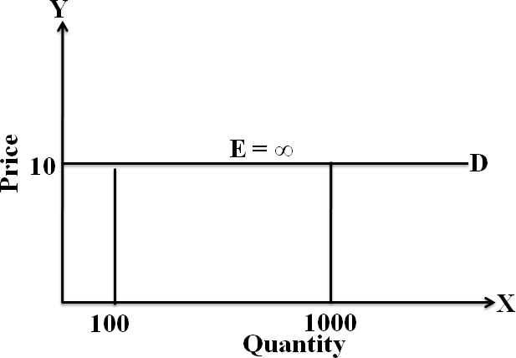
line demand curve parallel to
the X- axis.
Price | Demand
10 | 100
10 | 1000

Ep = ((Q2 − Q1)/Q1) /((P2 − P1)/P1)

𝐸𝑝 = (1000 − 100)/100 /(10 − 10)/10 = ∞

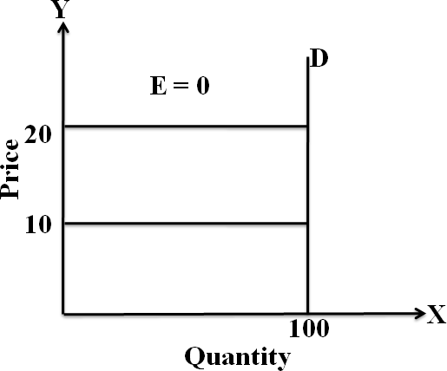
The demand curve is horizontal straight line. It shows the at Rs. 10 price any quantity is demanded and if price increases, the consumer will not purchase the commodity.

Perfectly Inelastic Demand

A commodity is said to have perfectly inelastic demand, when even a large change in price of the commodity causes no change in the quantity demanded. The elasticity coefficient of perfectly in elastic demand is E_{p} = 0.
The shape of the demand curve for perfectly inelastic is vertical as shown below.

Price | Demand
10 | 100
20 | 100
Ep = ((Q2 − Q1)/Q1) /((P2 − P1)/P1)

𝐸𝑝 = (100 − 100)/100 /(20 − 10)/10 = 0

When price increases from Rs. 10 to Rs.20, the quantity demanded remains the same. In other words the response of demand to a change in Price is nil. In this case ‗E‘=0.

Relatively elastic demand:

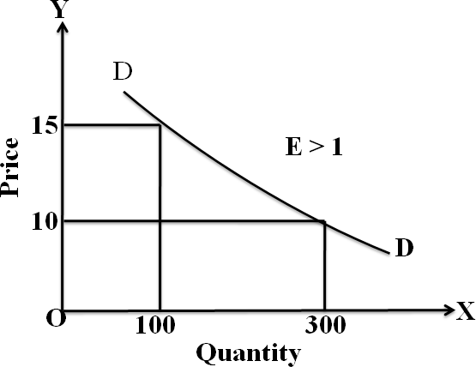
Demand changes more than proportionately to a change in price. i.e. a small change in price leads to a very big change in the quantity demanded. In this case E > 1. This demand curve will be flatter.

Price | Demand
10 | 300
15 | 100

Ep = ((Q2 − Q1)/Q1) /((P2 − P1)/P1)

𝐸𝑝 = (100 − 300)/300 /(15 − 10)/10 = −1.34

When price increases from Rs.10 to Rs.15, quantity demanded decreases from 300units to 100units which is larger than the change in price.

Relatively in-elastic demand.

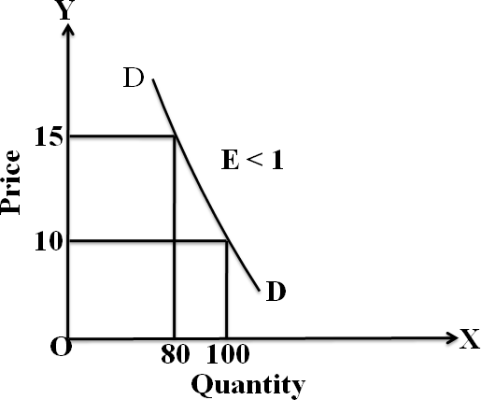
Quantity demanded changes less than proportional to a change in price. A large change in price leads to small change in quantity demanded. Here E < 1. Demanded carve will be
steeper.

Price | Demand
10 | 100
15 | 80

Ep = ((Q2 − Q1)/Q1) /((P2 − P1)/P1)

𝐸𝑝 = (80 − 100)/100 /(15 − 10)/10 = −0.40

When price increases from Rs.10 to Rs.15 quantity demanded decreases from 100units to units, which is smaller than the change in price.

Unitary elasticity of demand:

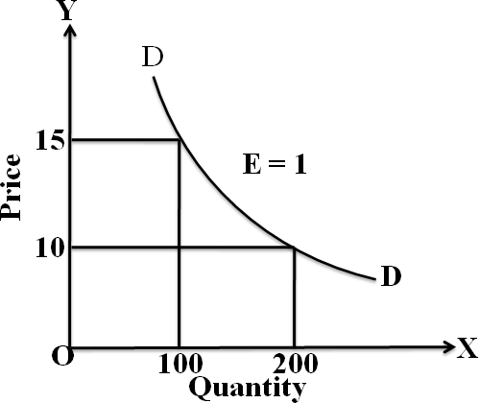
The change in demand is exactly equal to the change in price. When both are equal, E=1 and elasticity is said to be unitary.

Price | Demand
10 | 200
15 | 100

Ep = ((Q2 − Q1)/Q1) /((P2 − P1)/P1)

𝐸𝑝 = (100 − 200)/200 /(15 − 10)/10 = −1

When price increases from Rs.10 to Rs.15, quantity demanded decreases from 200units to 100units. Thus a change in price has resulted in an equal change in quantity demanded so price elasticity of demand is equal to unity.
- Income elasticity of demand:

Income elasticity of demand shows the change in quantity demanded as a result of a change in income. Income elasticity of demand may be slated in the form of a formula.
Proportionate change in the quantity demand of commodity

E_{I} ₌ Income Elasticity =

Proportionate change in the income of the people

Q2 − Q1 E = Q1 I I2 − I1
I1
Q₁ = Old demand Q₂ = New demand I₁ = Old income
I₂ = New income

- Cross elasticity of Demand:

A change in the price of one commodity leads to a change in the quantity demanded of another commodity. This is called a cross elasticity of demand. The formula for cross elasticity of demand is:
Proportionate change in the quantity demand of commodity ―X” E_{C} = Cross elasticity =
Proportionate change in the price of commodity ―Y”

- In case of substitutes, cross elasticity of demand is positive. Eg: Coffee and Tea
When the price of coffee increases, Quantity demanded of tea increases. Both are substitutes.

- In case of compliments, cross elasticity is negative. If an increase in the price of one commodity leads to a decrease in the quantity demanded of another and vice versa.
When price of car goes up, the quantity demanded of petrol decreases. The cross- demanded curve has negative slope.

Advertisement elasticity of demand:

It refers to increase in the sales revenue because of change in the advertising expenditure. In other words, there is a direct relationship between the amount of money spent on advertising and its impact on sales. Advertising elasticity is always positive.
Proportionate change in the quantity demand of commodity
E_{A} = Advertisement elasticity =

Proportionate change in advertisement costs

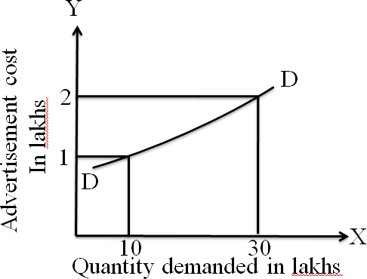

SIGNIFICANCE / IMPORTANCE OF ELASTICITY OF DEMAND

(or)

ELASTICITY OF DEMAND IN DECISION-MAKING

The concept of elasticity is very useful to the producers and policy makers alike. It is very valuable tool to decide the extent of increase or decrease in price for a desired change in the quantity demanded for the products and services in the firm or the economy. The practical importance of this concept will be clear from the following application.

Price fixation:

A knowledge of elasticity of demand may help the businessman to make a decision whether to cut or increase, the price of his product or to shift the burden of any additional cost of production on to the consumers by charging high price. Each seller under monopoly and imperfect competition has to take into account elasticity of demand while fixing the price for his product. If the demand for the product is inelastic, he can fix a higher price.

Production:

The elasticity of demand helps the businessman to decide about production. A businessman choose the optimum product mix on the basis of elasticity of demand for various products. The products having more elastic demand are preferred by the businessman. The sale of such products can be increased with a little reduction in their prices. Hence elasticity of demand helps the producers to take correct decision regarding the level of output to be produced.

prices of factors of production:

A factor with an inelastic demand can always command a higher price as compared to a factor relatively elastic demand. This helps the trade unions in knowing that where they can easily get the wage rate increased. Bargaining capacity of trade unions depend upon elasticity of demand for workers services. Elasticity of demand also helps in the determination of rewards for factors of production. For example, if the demand for labour is inelastic, trade unions will be successful in raising wages. It is applicable to other factors of production.

International Trade:

Elasticity of demand helps in finding out the terms of trade between two countries. Terms of trade refers to the rate at which domestic commodity is exchanged for foreign commodities. Terms of trade depends upon the elasticity of demand of the two countries for each other goods. A country will benefit from international trade when it fixes lower price for exports items whose demand is price elastic and high price for those exports whose demand is inelastic. The demand for imports should be elastic for a fall in price and inelastic for raise in price. The terms of trade between the two countries also depends upon the

elasticity of demand of exports and imports. If the demand is inelastic, the terms of trade will be in favour of the seller country. If the demand is elastic, the terms of trade will be in favour of the buyer country.

Tax policies:

The government can impose higher taxes and collect more revenue if the demand for the commodity on which a tax is to be levied is inelastic. On the other hand, in case of a commodity with elastic demand high tax rates may fail to bring in the required revenue for the government. Elasticity of demand helps the government in formulating tax policies. For example, for imposing tax on a commodity, the Finance Minister has to take into account the elasticity of demand.

Nationalization of public utilities:

The nationalization of public utility services can also be justified with the help of elasticity of demand. Demand for public utilities such as electricity, water supply, post and telegraph, public transportation etc., is generally inelastic in nature. If the operation of such utilities is left in the hands of private individuals, they may exploit the consumers by charging high prices. Therefore, in the interest of general public, the government owns and runs such services.

